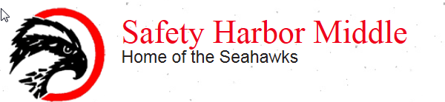

SAC Committee
Meeting Minutes
March 2, 2021 at 5:00 p.m.

Mr. Boulieris called the meeting to order at 5:00 pm.
Members in Attendance: Danny Boulieris, Matthew Miller, Sarah Williamson, Toni Powers, Tracey Birch, Dan Howell, Melissa Walls, Luis Moralis, Arlene Welninski, Rafaela Venzi-Vialle, Andrea Ewing-Watson

- Approval of February Minutes: Tracey Birch made motion to approve the SAC minutes from February 2nd, 2021. Melissa Walls seconded.

- Officers: Mr. Boulieris asked if anyone would like to be SAC President or Treasurer. Melissa Walls offered to be the Secretary. If anyone is interested, please email Mr. Boulieris.

- Discovery Night and articulation to 6th grade: Will be a virtual event held on Tuesday, March 9th, 2021. Mr. Boulieris asked for any suggestions from SAC for the articulation event. One suggestion was to provide support with understanding the technology used in middle school for parents and students.

- Interdisciplinary planning for Gifted and Talented Cohort: Mrs. Welninski made a request to have four teachers work on interdisciplinary planning this summer. They would create a curriculum map that would help provide resources and make curriculum connections with 6th grade history and science, especially focusing on helping students with reading nonfiction texts and writing essays. The amount would not exceed $1500. Luis Morales made a motion to accept the proposal and provide the funds. He requested that there would be feedback shared with the SAC mid-year next school year. Seconded by Tracey Birch.

- FSA and EOC/Motivation: Mr. Boulieris asked if the SAC had any suggestions with how to motivate kids intrinsically or extrinsically as they start to prepare to have kids taking the upcoming standardized assessments. Discussed in the past the school has used the “Pump it Up” program. Suggestion to have current students, high school students and community members do PSA announcements to help motivate the students.

- Modified Dress Code: Discussion moved to the April SAC meeting.

The next SAC meeting is scheduled for April 6^{th,} 202 at 5:00 p.m.

The meeting adjourned at 5:49 p.m.

